EPIC
Epic - Design the Website Creation Page in Tilda
Epic Description-
The purpose of this Epic is to design a visually appealing, intuitive, and user-friendly Website Creation Page using the Tilda website builder. The page will allow users to start creating their website by entering basic project information, choosing template layouts, and previewing the selected design.

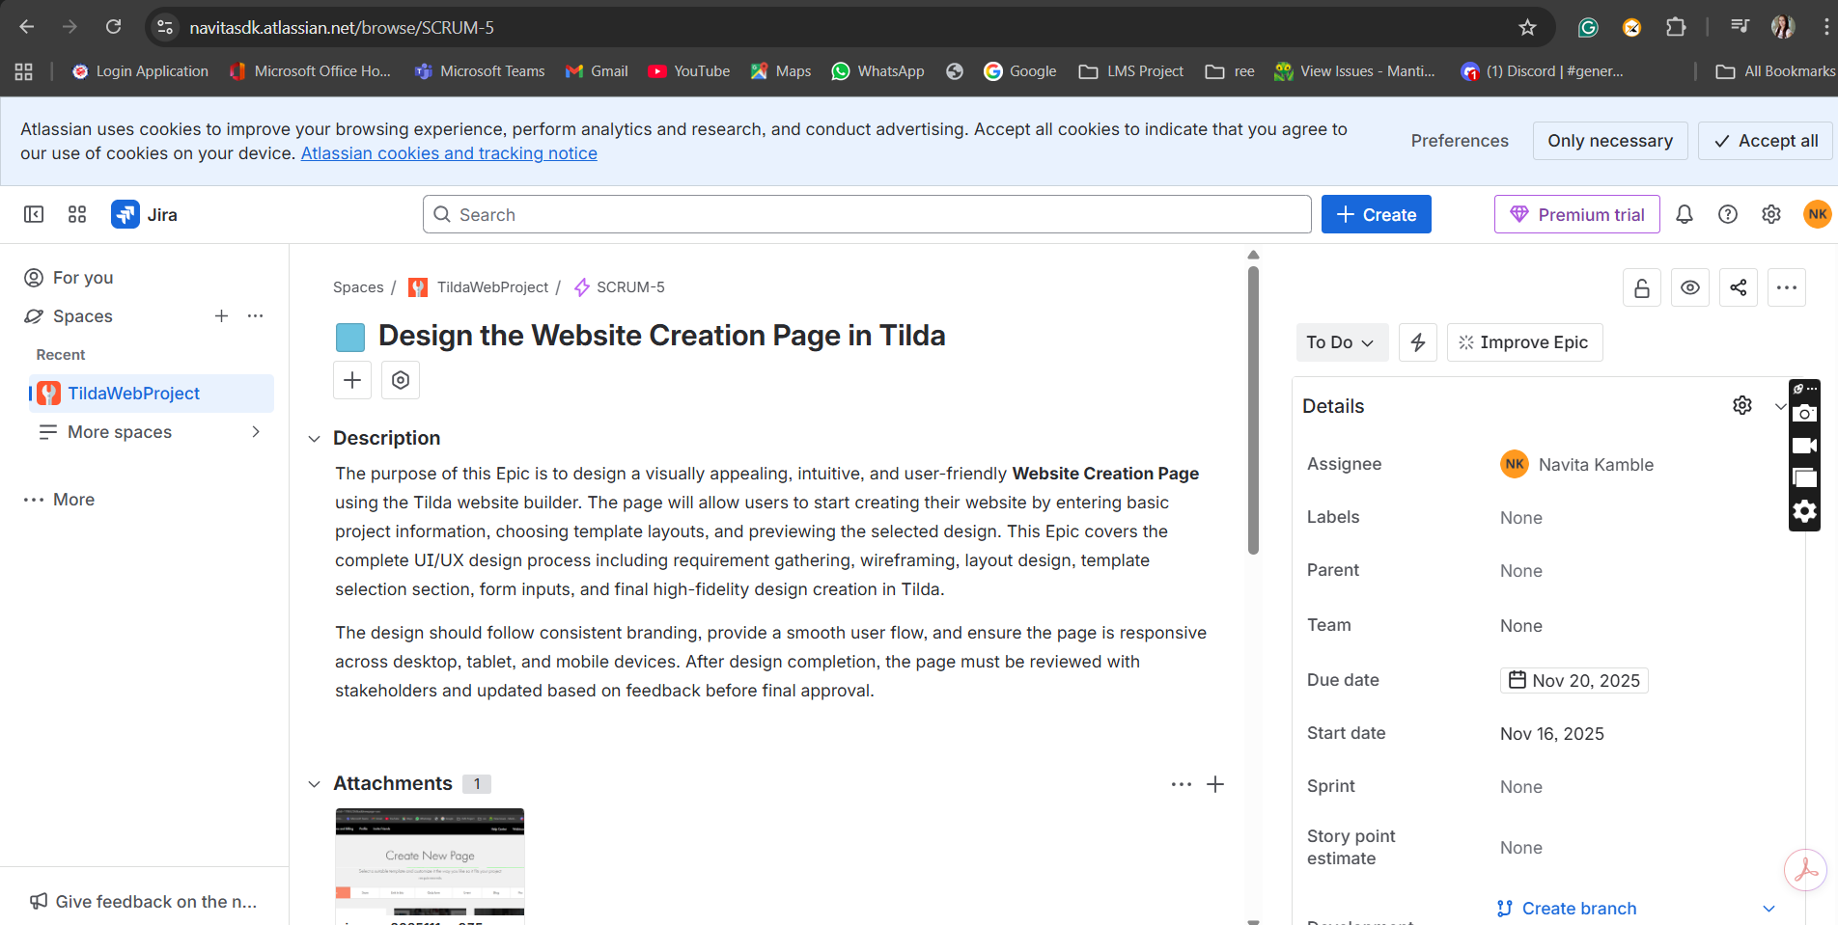

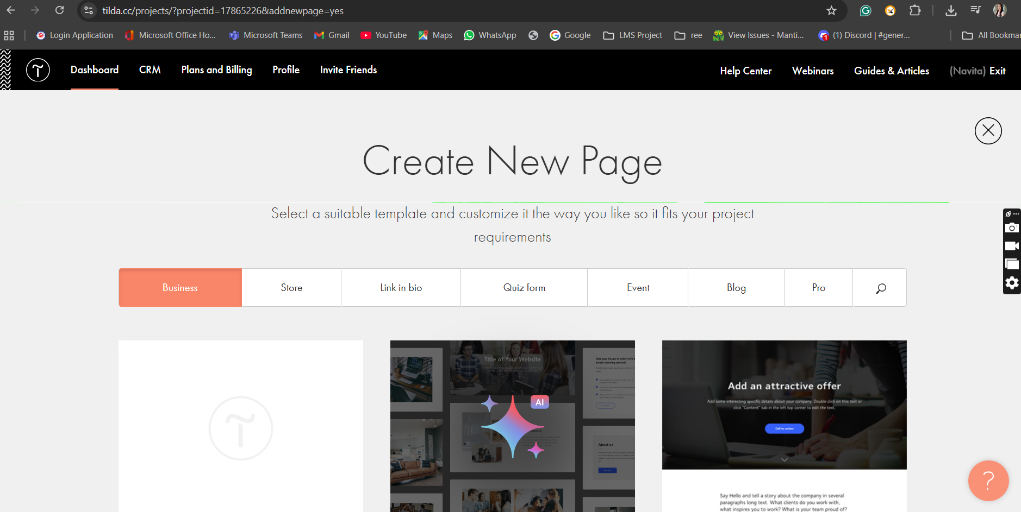

User Story- 1

Design High-Fidelity UI for Create Page

Story Description:
As a designer, I want to design a high-fidelity UI so users get a modern and visually appealing experience.

.

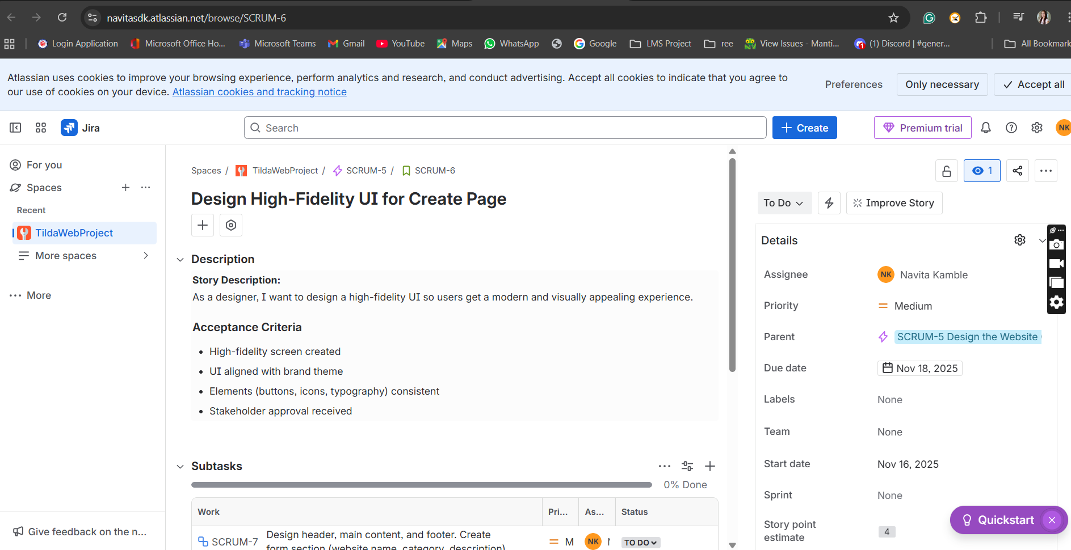

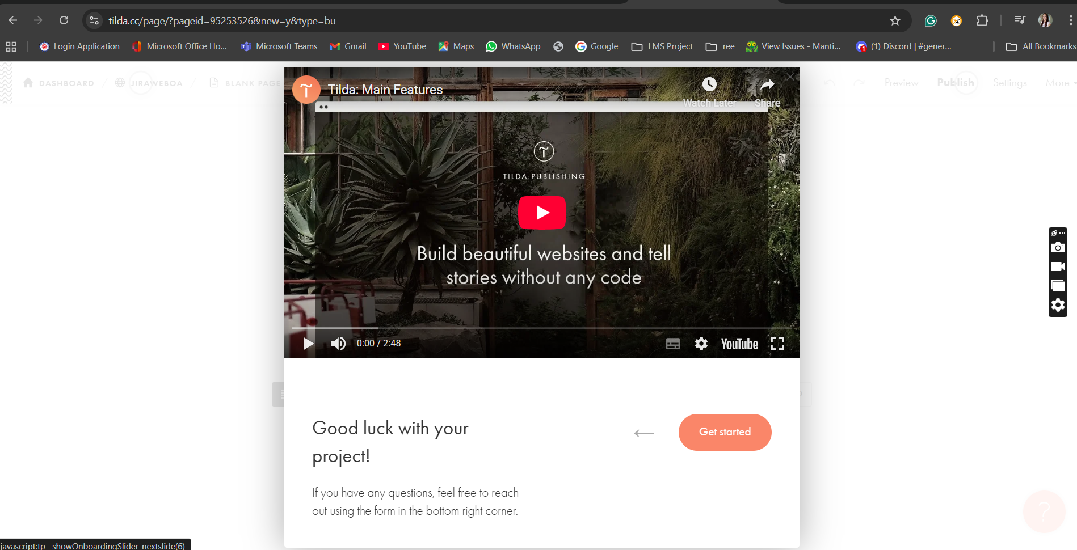

Sub Task-1

Design header, main content, and footer & Create form section (website name, category, description)

Description-Design and implement a structured and user-friendly form section on the Create Page to capture essential website information from the user. The form should include input fields for Website Name, Category, and Description, and should be aligned with the overall UI theme and layout.

User Stroy-2
Review & QA
Story Description:
As a QA tester, I want to verify the Create Page so that it works smoothly on all devices.

Acceptance Criteria:
- No UI alignment issues
- All elements clickable and responsive
- Page loads correctly on desktop, tablet, mobile
- No spelling or content issues

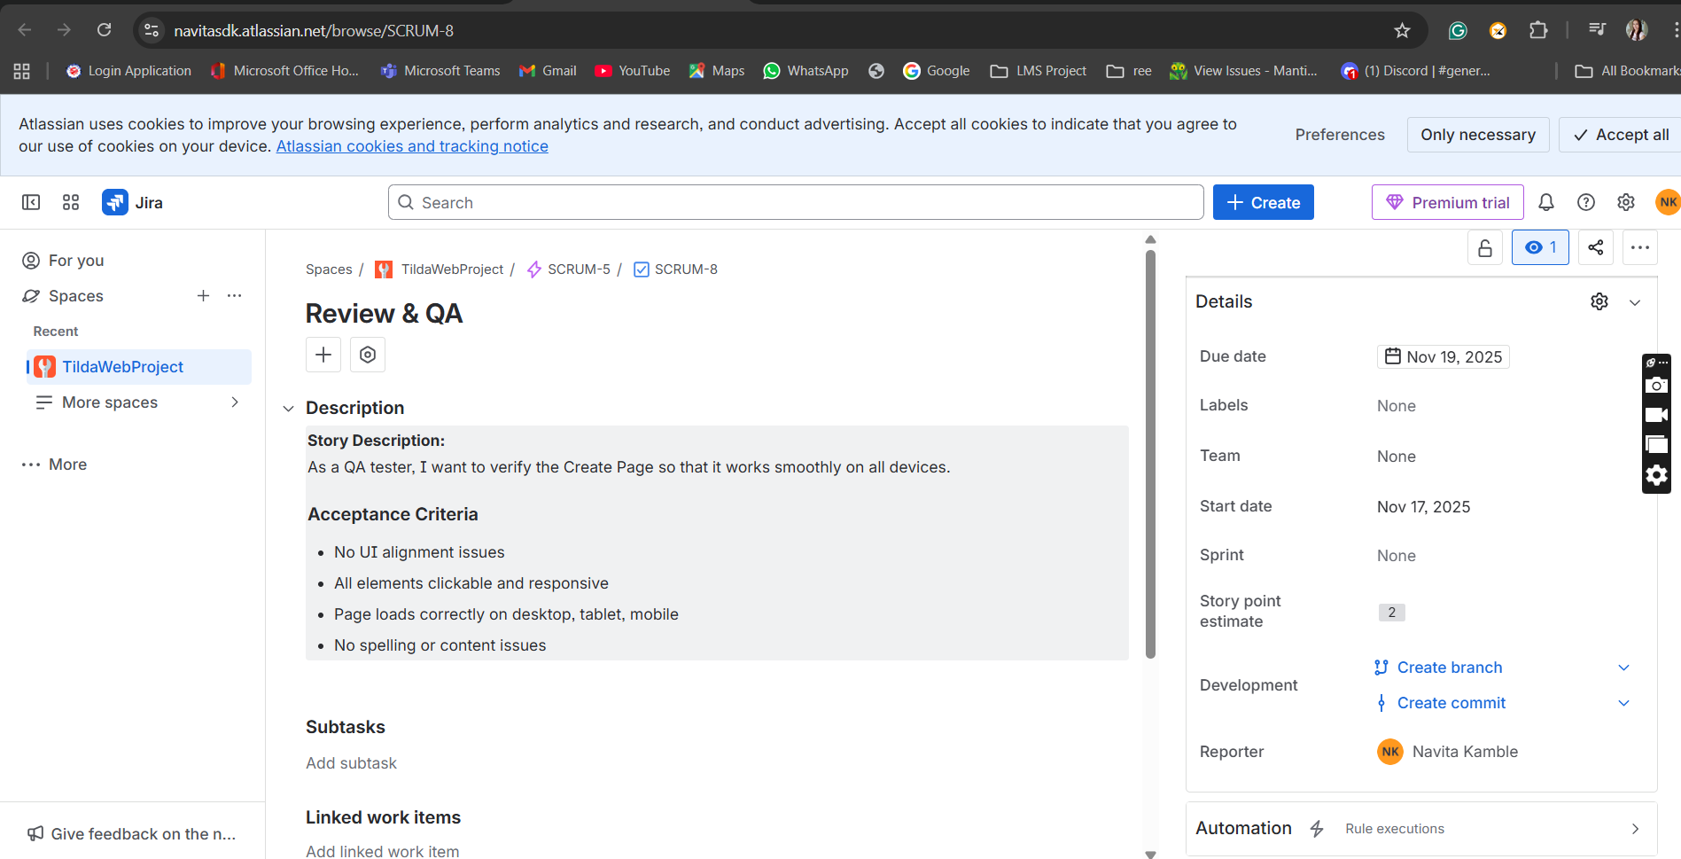

SubTask-
UI/UX & Responsive Testing
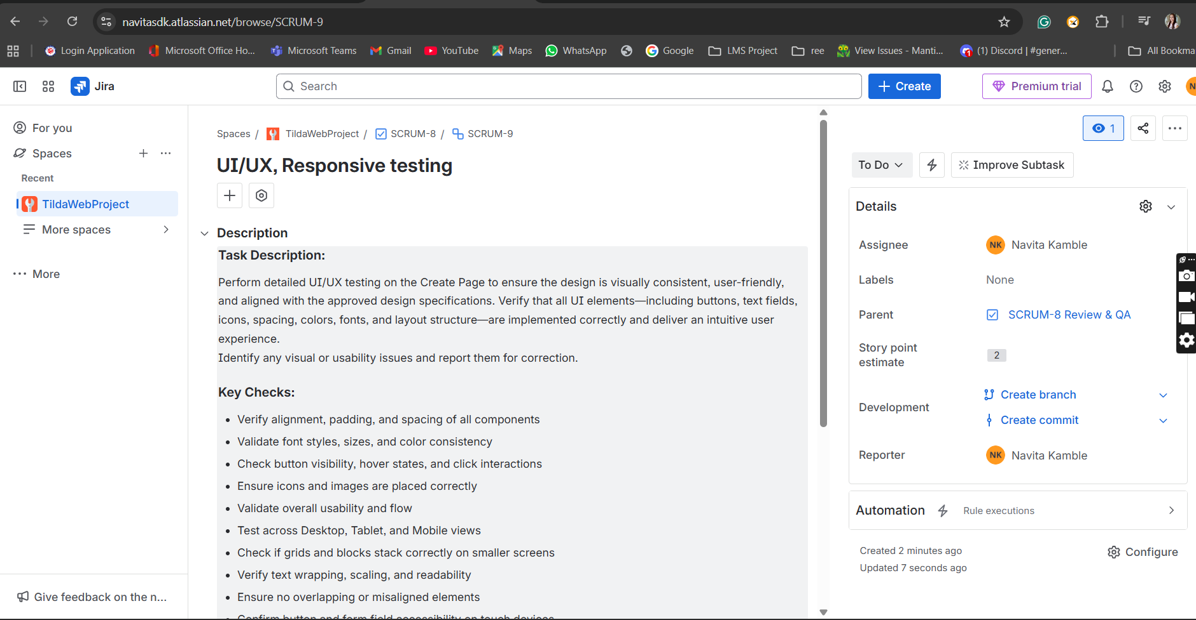

Moved All From backlog to Sprint

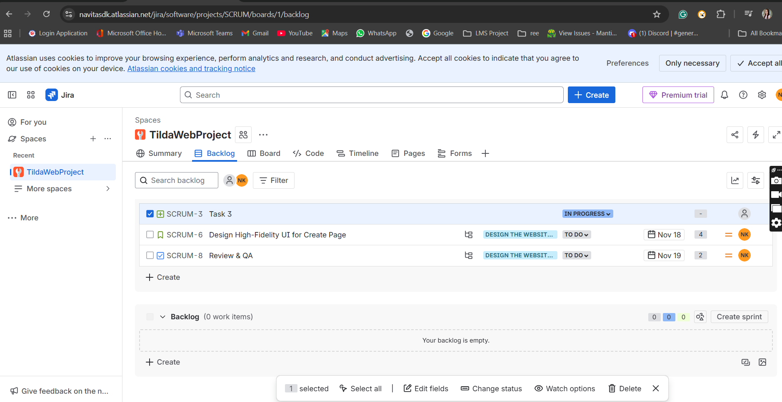

Defect Created in User story-
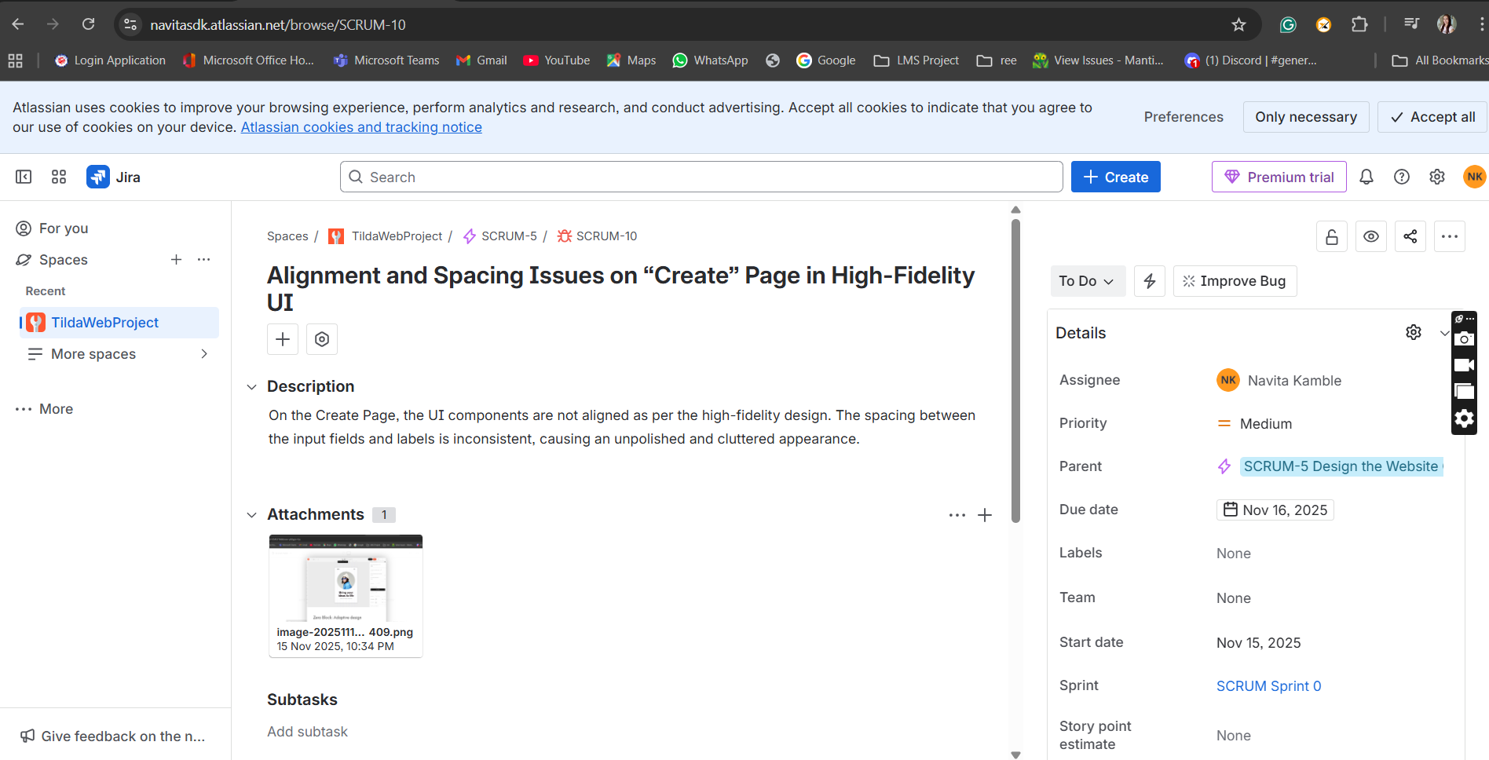

All the User stories completed-
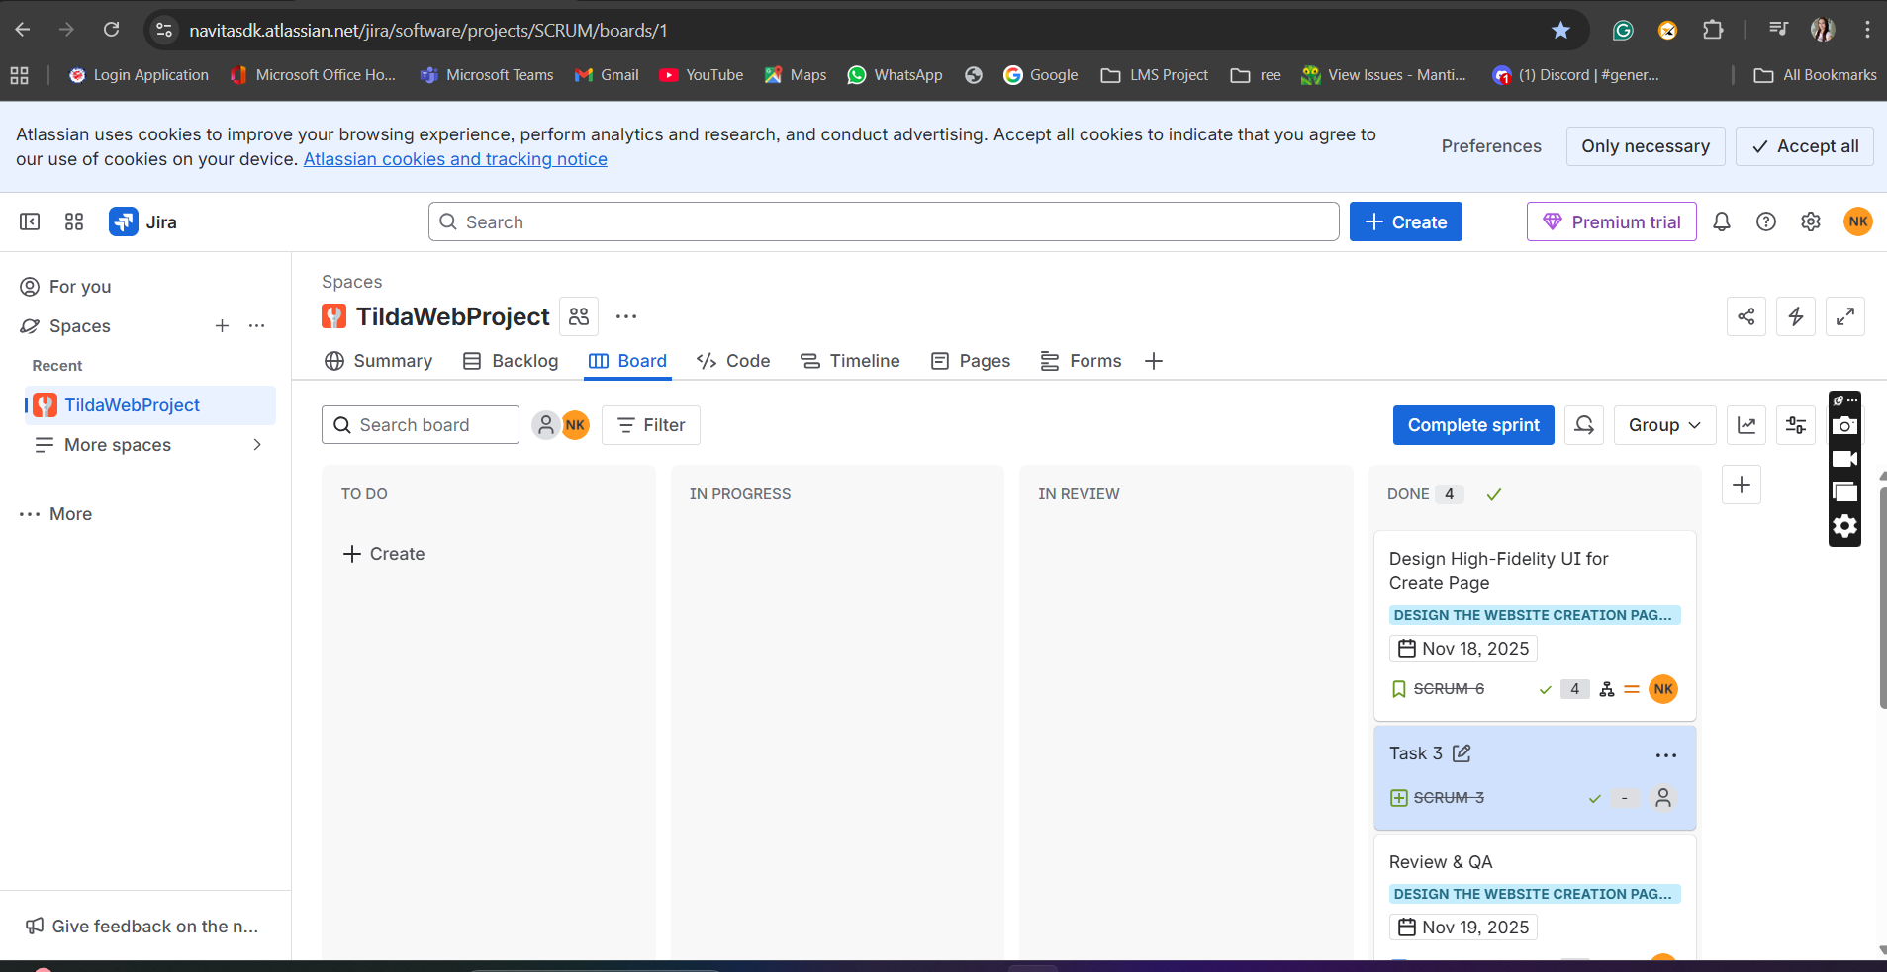

Sprint Completed-
